AMAZON’S 100 BOOKS TO READ IN YOUR LIFE

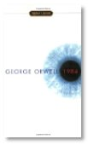  Meet Big Brother  1984 by George Orwell  Print | Kindle | 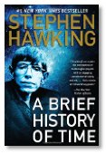  Explore the Universe  A Brief History of Time by Stephen Hawking  Print | 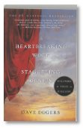  Memoir as metafiction  A Heartbreaking Work of Staggering Genius by Dave Eggers  Print | Kindle | A child-soldier's story  A Long Way Gone by Ishmael Beah  Print | Kindle | 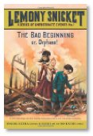  Wicked good fun  A Series of Unfortunate Events #1: The Bad Beginning: The Short-Lived Edition by Lemony Snicket  Print | Kindle

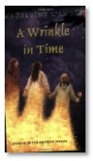  The 60s kids classic  A Wrinkle in Time by Madeleine L'Engle  Print | Kindle | 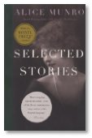  A short-form master  Alice Munro: Selected Stories by Alice Munro  Print | Kindle | 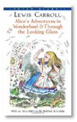  Go down the rabbit hole  Alice in Wonderland by Lewis Carroll  Print | Kindle | 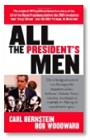  Unseated a president  All the President's Men by Bob Woodward and Carl Bernstein  Print | Kindle | 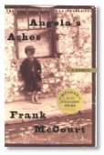  An Irish-American Memoir  Angela's Ashes: A Memoir by Frank McCourt  Print | Kindle

The angst of adolescence  Are You There, God? It's me, Margaret by Judy Blume  Print | Kindle | A literary page turner  Bel Canto by Ann Patchett  Print | Kindle | 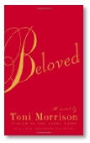  The ghosts of slavery  Beloved by Toni Morrison  Print | Kindle | 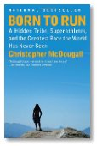  Why and how we run  Born To Run - A Hidden Tribe, Superathletes, and the Greatest Race the World Has Never Seen by Christopher McDougall  Print | Kindle | 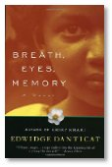  A journey from Haiti  Breath, Eyes, Memory by Edwidge Danticat  Print | Kindle

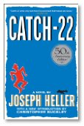  Launched its own catchphrase  Catch-22 by Joseph Heller  Print | Kindle | 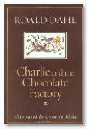  Vintage Roald Dahl  Charlie and the Chocolate Factory by Roald Dahl  Print | Kindle | 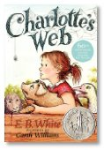  The timeless classic  Charlotte's Web by E.B. White  Print | 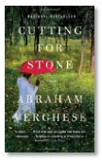  Ambitious and humane  Cutting For Stone by Abraham Verghese  Print | Kindle | 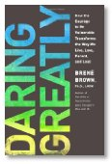  Vulnerability breeds courage  Daring Greatly: How the Courage to Be Vulnerable Transforms the Way We Live, Love, Parent, and Lead by Brene Brown  Print | Kindle

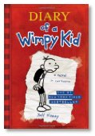  For reluctant readers  Diary of a Wimpy Kid, Book 1 by Jeff Kinney  Print | Kindle | A science fiction classic  Dune by Frank Herbert  Print | Kindle | 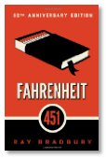  "It was a pleasure to burn."  Fahrenheit 451 by Ray Bradbury  Print | Kindle | 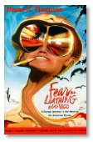  Gonzo journalism takes flight  Fear and Loathing in Las Vegas: A Savage Journey to the Heart of the American Dream by Hunter S. Thompson  Print | Kindle | 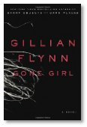  Marriage can be a real killer  Gone Girl by Gillian Flynn  Print | Kindle

First published in 1947  Goodnight Moon by Margaret Wise Brown  Print | 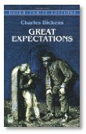  Dickens' best novel  Great Expectations by Charles Dickens  Print | Kindle | 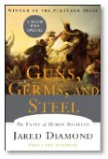  Understanding societies  Guns, Germs, and Steel: The Fates of Human Societies by Jared M. Diamond  Print | Kindle | 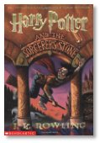  Meet the boy wizard  Harry Potter and the Sorcerer's Stone by J.K. Rowling  Print | Kindle | 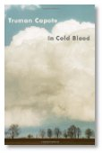  True crime at its best  In Cold Blood by Truman Capote  Print | Kindle

Award-winning short story debut  Interpreter of Maladies by Jhumpa Lahiri  Print | Kindle | 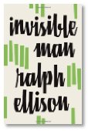  A literary milestone  Invisible Man by Ralph Ellison  Print | Kindle | 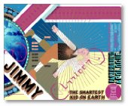  A brilliant graphic novel  Jimmy Corrigan: Smartest Kid on Earth by Chris Ware  Print | Don't eat while you read this  Kitchen Confidential by Anthony Bourdain  Print | Kindle | One of the best of 2013  Life After Life by Kate Atkinson  Print | Kindle

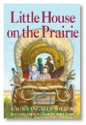  Childhood on the frontier  Little House on the Prairie by Laura Ingalls Wilder  Print | Nabokov's triumph  Lolita by Vladimir Nabokov  Print | Kindle | A Latin American masterpiece  Love in the Time of Cholera by Gabriel Garcia Marquez  Print | 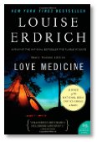  A saga set on the reservation  Love Medicine by Louise Erdrich  Print | Kindle | 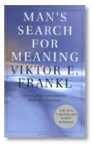  A life-changing book  Man's Search for Meaning by Viktor Frankl  Print | Kindle

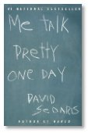  Funny and poignant  Me Talk Pretty One Day by David Sedaris  Print | Kindle | 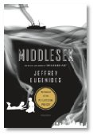  A beautifully-written novel  Middlesex by Jeffrey Eugenides  Print | Kindle | 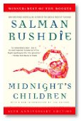  Rushdie's breakthrough  Midnight's Children by Salman Rushdie  Print | Kindle | Lewis hits it out of the park  Moneyball by Michael Lewis  Print | Kindle | 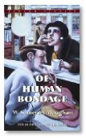  A writer's writer  Of Human Bondage by W. Somerset Maugham  Print | Kindle

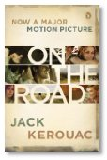  The essence of the Beats  On the Road by Jack Kerouac  Print | Kindle | A remarkable woman's story  Out of Africa by Isak Dinesen  Print | Kindle | A groundbreaking graphic novel  Persepolis by Marjane Satrapi  Print | 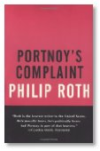  Roth at his finest  Portnoy's Complaint by Philip Roth  Print | Kindle | The perennial favorite  Pride & Prejudice by Jane Austen  Print | Kindle

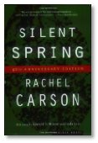  The birth of ecology  Silent Spring by Rachel Carson  Print | Kindle | The absurdist WW2 novel  Slaughterhouse-Five by Kurt Vonnegut  Print | Kindle | How Lincoln led  Team of Rivals by Doris Kearns Goodwin  Print | Kindle | 19th Century high society  The Age of Innocence by Edith Wharton  Print | Kindle | Chabon's magnum opus  The Amazing Adventures of Kavalier and Clay by Michael Chabon  Print | Kindle

A classic modern autobiography  The Autobiography of Malcolm X by Malcolm X and Alex Haley  Print | 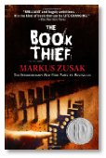  The international sensation  The Book Thief by Markus Zusak  Print | Kindle | 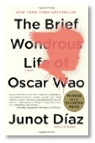  The trials of a "ghetto nerd"  The Brief Wondrous Life of Oscar Wao by Junot Diaz  Print | Kindle | 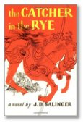  Meet Holden Caulfield  The Catcher in the Rye by J.D. Salinger  Print | 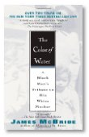  Exploring a mother's past  The Color of Water by James McBride  Print | Kindle

Great, but divisive  The Corrections by Jonathan Franzen  Print | Kindle | A triumph of narrative nonfiction  The Devil in the White City: Murder, Magic, and Madness at the Fair that Changed America by Erik Larson  Print | Kindle | 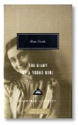  Moving and eloquent  The Diary of Anne Frank by Anne Frank  Print | Kindle | 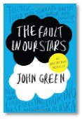  A soulful young adult novel  The Fault in Our Stars by John Green  Print | Kindle | 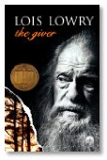  Classic dystopia  The Giver by Lois Lowry  Print | Kindle

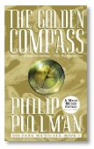  Pullman's fantasy classic  The Golden Compass: His Dark Materials by Philip Pullman  Print | Kindle | 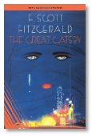  The rich are different.. ..  The Great Gatsby by F. Scott Fitzgerald  Print | Kindle | Feminist speculative fiction  The Handmaid's Tale by Margaret Atwood  Print | Kindle | 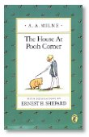  A boy, a bear, a honeypot  The House At Pooh Corner by A. A. Milne  Print | Kindle | 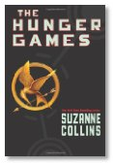  Reality tv writ large  The Hunger Games by Suzanne Collins  Print | Kindle

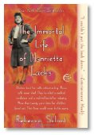  Race, ethics, and medicine  The Immortal Life of Henrietta Lacks by Rebecca Skloot  Print | Kindle | A darkly funny memoir  The Liars' Club: A Memoir by Mary Karr  Print | Kindle | 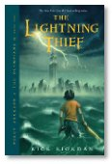  Monsters, Mythology, and a boy  The Lightning Thief (Percy Jackson and the Olympians, Book 1) by Rick Riordan  Print | Kindle | 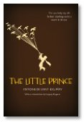  Unique and universal  The Little Prince by Antoine de Saint-Exupéry  Print | 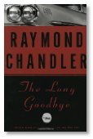  First-rate Chandler Noir  The Long Goodbye by Raymond Chandler  Print | Kindle

The history of terrorism  The Looming Tower: Al-Qaeda and the Road to 9/11 by Lawrence Wright  Print | Kindle | 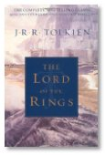  One ring to rule them all  The Lord of the Rings by J.R.R. Tolkien  Print | Kindle | 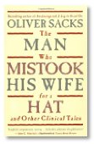  A deeply human account  The Man Who Mistook His Wife For A Hat: And Other Clinical Tales by Oliver Sacks  Print | Kindle | 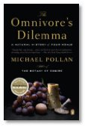  The origins of food  The Omnivore's Dilemma: A Natural History of Four Meals by Michael Pollan  Print | Kindle | An odd and original journey  The Phantom Tollbooth by Norton Juster  Print | Kindle

Missionaries in Africa  The Poisonwood Bible: A Novel by Barbara Kingsolver  Print | Kindle | 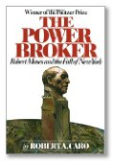  The Enforcer  The Power Broker: Robert Moses and the Fall of New York by Robert A. Caro  Print | 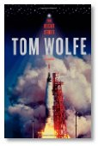  The inner life of astronauts  The Right Stuff by Tom Wolfe  Print | Kindle | 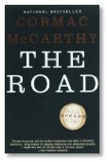  This way to the apocalypse  The Road by Cormac McCarthy  Print | Kindle | A modern classic  The Secret History by Donna Tartt  Print | Kindle

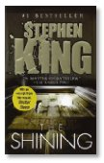  Chilling and thrilling  The Shining by Stephen King  Print | Kindle | Existentialist fiction  The Stranger by Albert Camus  Print | Kindle | 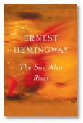  Meet the Lost Generation  The Sun Also Rises by Ernest Hemingway  Print | Kindle | 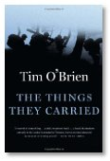  The best book on Vietnam  The Things They Carried by Tim O'Brien  Print | Kindle | 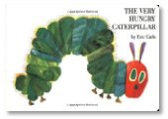  Baby's first book  The Very Hungry Caterpillar by Eric Carle  Print

Mole, Toad, Rat, and Badger  The Wind in the Willows by Kenneth Grahame  Print | 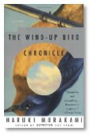  From the modern Japanese master  The Wind-Up Bird Chronicle: A Novel by Haruki Murakami  Print | Kindle | 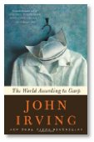  Beware the "Undertoad"  The World According to Garp by John Irving  Print | 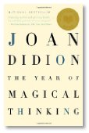  Life, Love, Death  The Year of Magical Thinking by Joan Didion  Print | Kindle | 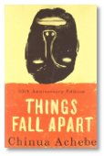  Tradition vs. change  Things Fall Apart by Chinua Achebe  Print | Kindle

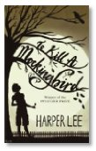  A beloved family story  To Kill a Mockingbird by Harper Lee  Print | 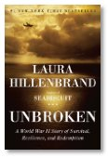  An American inspiration  Unbroken: A World War II Story of Survival, Resilience, and Redemption by Laura Hillenbrand  Print | Kindle | 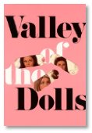  Addictively entertaining  Valley of the Dolls by Jacqueline Susann  Print | Kindle | 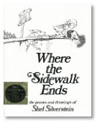  The joys of imagination  Where the Sidewalk Ends by Shel Silverstein  Print | 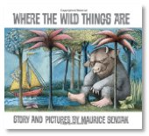  Let the wild rumpus start!  Where the Wild Things Are by Maurice Sendak  Print

